DEPARTMENT OF ENGLISH
List of students having further studies and placement
2018-2019
- Name: Lalhriatpuia Hauhnar
Course/Designation: General Manager
Institution/Employer: Zote Motors Pvt Ltd
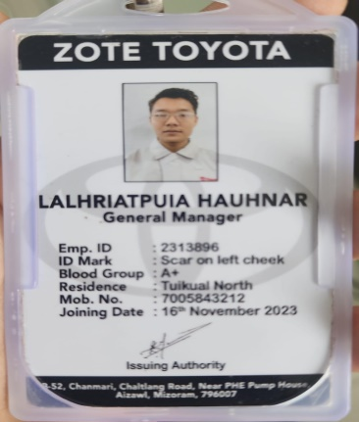
- Name: Rona lalronungi
Course/Designation: Advocate
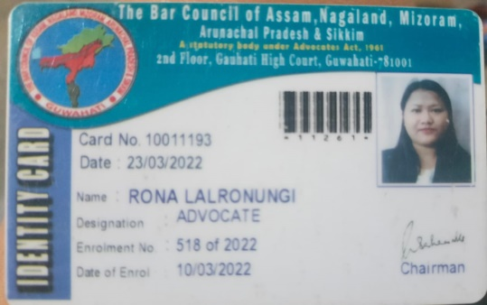

- Name: Vincent Lalngaihdama
Course/Designation: Bachelor of divinity
Institution/Employer: Aizawl Theological College
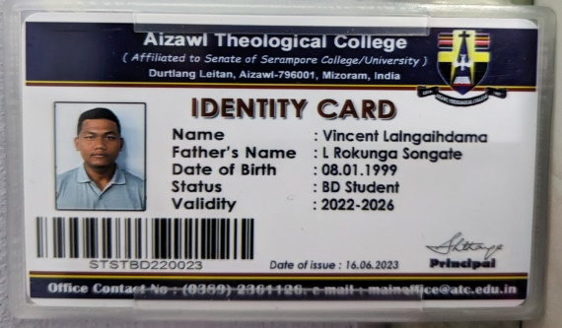

- Name: V. Lalsiamthari
Course/Designation: Lobby Ambassador- Guest Services
Institution/employer: City Centre Rotana Doha, Qatar
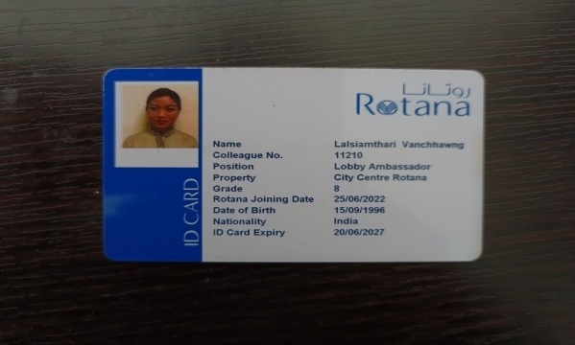
- Name: Abisagi Lalrinfeli
Course/Designation: Bachelor of education (B.ED)
Institution/employer: Mizoram University
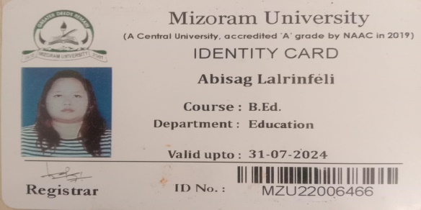

2019-2020
- NAME: Babie K Lalsangzuali
Course/designation: Advocate
Institution/employer: Aizawl District Court
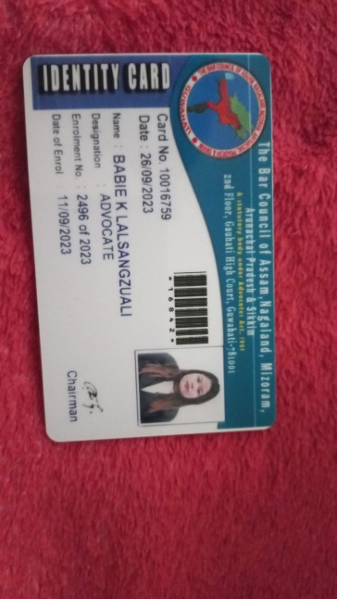
- Name: Vanlaldinpuii
Course/Designation: Advocate
Institution/employer: Aizawl district Court
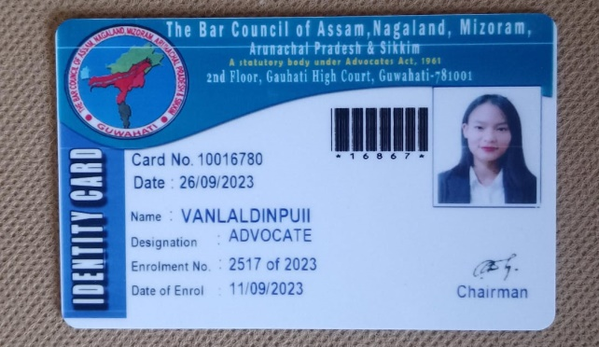

2020-2021
- Name: Eric Lalnunpuia
Course/designation: M.A.
Institution/employer: Mizoram University
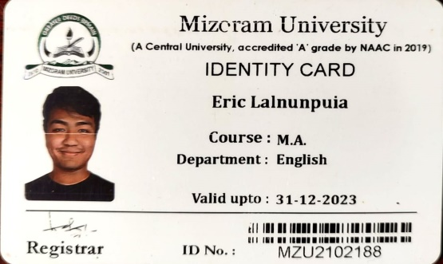
2021-2022
- Name: TC Vanlalthasangkima
Course/designation: M.A
Institution/employer: IGNOU
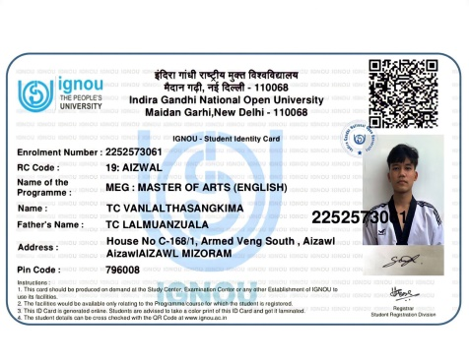
- Name: Ruthi Lalbiaknungi
Course/designatiom: M.A
Institution/employer: St Joseph University Nagaland
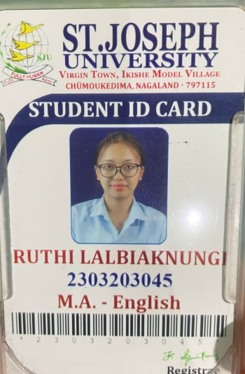
- Name: Johny Lalbiakzuala
Course/designation: M.A
Institution/Employer: ICFAI University
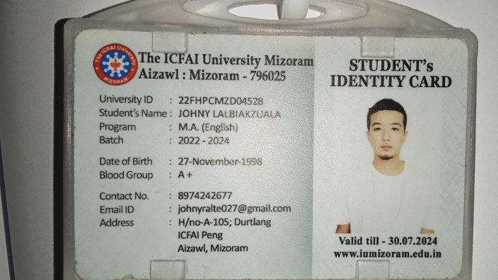
- Name: Lalremkimi
Course/designation: M.A
Institution/emloyer: IGNOU
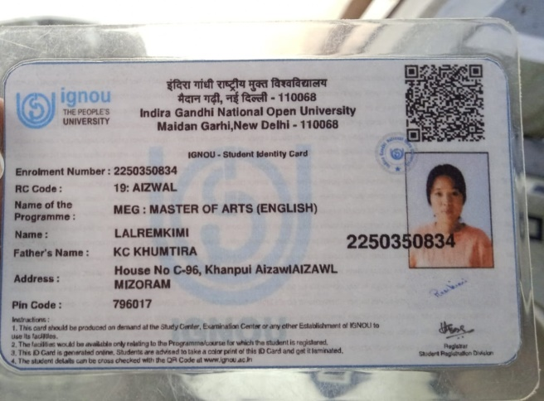

2022-2023
- Name : Pretina Daorili Hlychho
Course/designation: MA English
Institution/employer : ICFAI University Mizoram
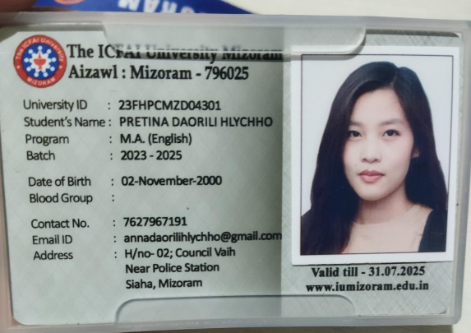
- Name: Malsawmzuali
Course/designation: M.A
Institution/employer: IGNOU
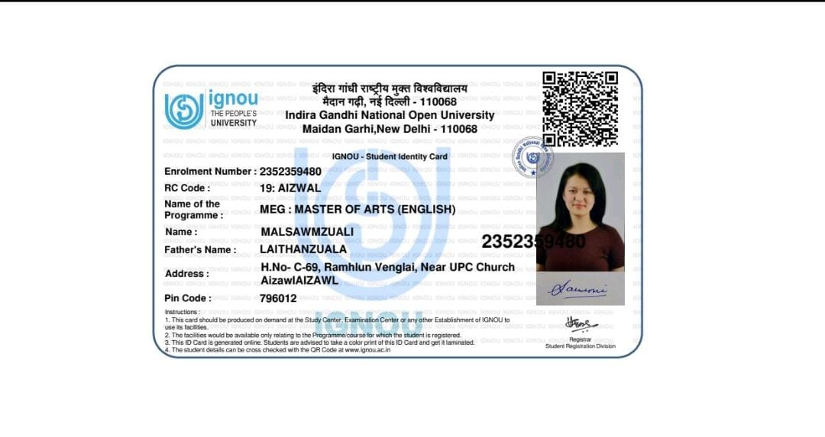
- Name: Marlyn Lalhlunchhungi
Course/Designation: Master of Arts
Institution/employer: IGNOU
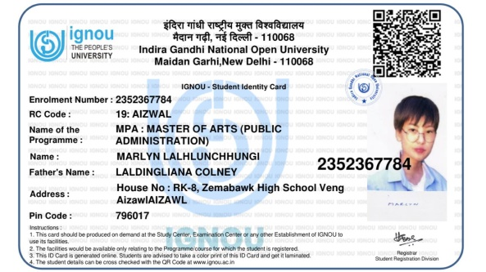
- Name: R. lalhmingmawii
Course/designation: MA English
Institution/employer : ICFAI University Mizoram
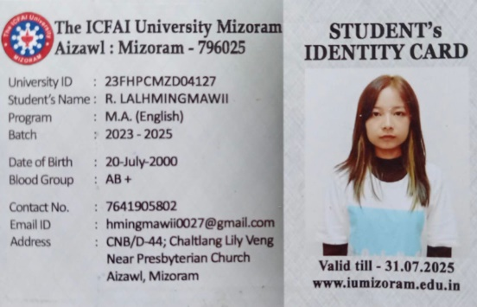
- Name: PCLalhruaizeli
Course/designation: Officer Sales
Institution/employer: Axis Bank
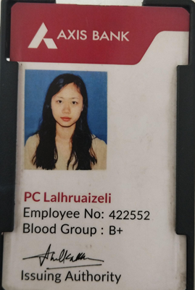
- Name: Malsawmropuia
Course/designation: MA English
Institution/employer : ICFAI University Mizoram

