DEPARTMENT OF ENGLISH
GOVERNMENT AIZAWL NORTH COLLEGE
INTERNATIONAL WEBINAR ON ‘LITERATURE, CULTURE & SOCIETY’ – A REPORT
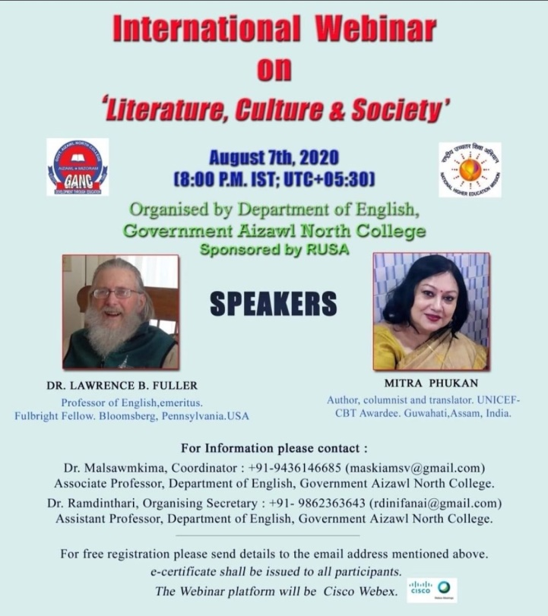

A webinar on ‘Literature, Culture & Society’ was held on August 7th, 2020 at 8:00 p.m (IST) : 5:30 A.M. (UTC) using Cisco Webex platform. The webinar started with a brief overview of the webinar context by Dr. Ramdinthari. The webinar addressed the following:
- The inter-relationship of literature and culture and society.
- The impact culture has on the production of literature of the time.
- How literature often reflects the social norms and values of the society in which it is produced.
Prof. S. Haukhanlian Mate, the Principal of the college delivered welcome address which was followed by introduction of the resource person Dr. Lawrence B. Fuller by Mr. Zohmingliana, HOD Department of English, GANC.
Dr. Lawrence B. Fuller is a Professor of English and a Fulbright Fellow from Bloomsberg, Pennsylvania USA. He emphasized on how literature leaves an indelible mark on society and culture, shaping narratives, challenging norms, and influencing the very fabric of one’s collective identity. He specifically focused on how literature has the power to shape societal narratives and challenge prevailing norms.
Ms. Ramdinsangi, Asst. Professor introduced the second speaker, Mitra Phukan who is an author, columnist and translator from Guwahati, Assam. Mitra Phukan elucidated on the role of literature as a tool for preserving culture. She spoke about the importance of folktales and legends which, passed down through generations, have kept traditions alive, fostered a sense of community, and provided moral guidance. She focused on how these become important in connecting people to their roots and to each other, thus creating a shared sense of identity.
The webinar received good response from the audience (teachers, students and research scholars from various colleges and universities) and gave good feedback.
The session ended with discussions and vote of thanks by Dr.Saroj Laldinpuii, Asso. Professor, Department of English.
The webinar was attended by 350 participants.
