****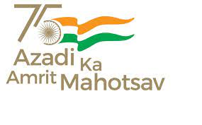**Govt. Aizawl North College**

**Ramhlun North Aiz Aizawl :Mizoram**

Website:http://www.ganc.mizoram.gov.in E-mail:govtanc@yahoo.com Phone:0389-2344069

**FACULTY DEVELOPMENT PROGRAMME**

DATE : 28.07.2022

PLACE : ROOM NO. 405

TIME : 11:00 Am – 2:30 Pm.

**Session I 11:00 Am – 12:30 Pm**

Chairman : Prof. R. Lalnuntluanga

Welcome Speech : Prof. S. Haukhanlian Mate, Principal

Resource Person : Prof. Lalbiakdiki Hnamte, Director,CDC, MZU

Intereaction :

***LUNCH - 12:30Pm – 01:00Pm***

**SESSION II 1:00Pm – 2:30Pm**

Chairman : Prof. R. Lalnuntluanga

Resource Person : Prof. Lalbiakdiki Hnamte, Director, CDC, MZU

Interaction :

Vote of thanks : Dr. Ramdinthari