****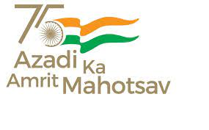**Govt. Aizawl North College**

**Ramhlun North Aizawl : Aizawl :Mizoram**

Website:http://www.ganc.mizoram.gov.in E-mail:govtanc@yahoo.com Phone:0389-2344069

-------------------------------------------------------------------------------------------------------------------------

**No.A.60014/2/08 - GANC/CIR/  *Dated Aizawl, the 10th October, 2022.***

**N O T I F I C A T I O N**

Women Development Cell, Govt. Aizawl North College leh LESDE Department tang kawp chuan naktuk ni **11th October, 2022 (Thawhlehni)** hian kan College-ah Skill Development Training **Room No. 405** a an neih dawn avangin hemi room-a class neih tur zawng zawng **chawlh (suspend)** tur a ni.

Sd/-

**(Prof. S. HAUKHANLIAN MATE)**

Principal

Govt. Aizawl North College

Aizawl : Mizoram

Memo. No.A.60014/2/08 - GANC/CIR/ Dated Aizawl, the 10th October, 2022.

Copy to:

1. Vice Principal, Govt. Aizawl North College for information.

2. Secretary, Women’s Development Cell, Govt. Aizawl North College for information and necessary action.

3. Guard File.

Principal

Govt. Aizawl North College

Aizawl : Mizoram

**Programme:**

Welcome Speech : Prof. S. Haukhanlian Mate, Principal

Introductory Speech : Dr. Angela Zothanpuii, Director LESDE

Solo : Juliana 3th Semester, GANC

Resource persons : 1) Lalmuanawma

2) Ramchianzela

3) Nghaka

Interaction Vote of thanks : Dr. Lalzarmawii, Associate Professor

Compere : Ms. Lalmuansangi, Assistant Professor