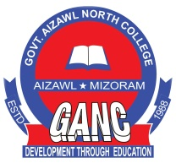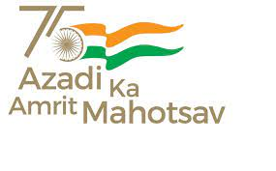**Govt. Aizawl North College**

**Ramhlun North Aiz Aizawl :Mizoram**

Website:http://www.ganc.mizoram.gov.in E-mail:govtanc@yahoo.com Phone:0389-2344069

**No.A.60014/2/08 - GANC/CIR/  *Dated Aizawl, the 20th December, 2023.***

**N O T I C E**

In compliance of letter No. 13016/1/2013-DTE(HTE) Dated Aizawl, the 15th Dcember, 2023, all Students of Govt. Aizawl North College are hereby informed to participate on the platform ‘Share your ideas’ to make India a developed nation by 2047 at the Vikrit Bharat2047. Voice of Youth platform which was launched by the Hon’ble Prime Minister on 11th Dec. 2023.

Students shall participate through the following:

1. Submit your ideas/feedback through Voice of Youth platform at Viksitbharat.mygovt.in on or before 25th December, 2023.

2. The ideas 4 Vikrit Bharat hashtag may be used across all social media platforms.

The following steps shall be followed while submitting Feeback on the portal

Step -1: Visit the MyGovportal(mygov.in) and proceed to the Visik Bharat Consultation section.

Step-2: Answer the following questions sequentially on the Portal:

How should Viksit Bharat look like in 2047 in different aspect.?

What do we need to do to reach this goal?

What can you do to make ViksitBharat@2047 possible?

Step-3: Provide the idea for the ViksitBharat@2047 and mention about your role/contribution towards making India as a developed nation.

Step-4: Submit the form along with your email ID and download the Certificate from your email

Step-5: Share your experience and your thoughts, pictures with certificates on social media with #Ideas4ViksitBharat.

Step-6: Send a copy of your Certificate on Whatsapp at 986230982

**(Prof.S.HAUKHANLIAN MATE)**

Principal

Govt. Aizawl North College

Aizawl:Mizoram