****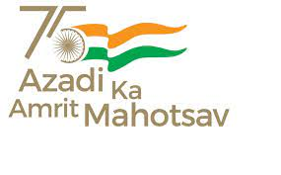**Govt. Aizawl North College**

**Ramhlun North Aizawl : Aizawl :Mizoram**

Website:http://www.ganc.mizoram.gov.in E-mail:govtanc@yahoo.com Phone:0389-2344069

**No.A.60014/2/08 - GANC/CIR/  *Dated Aizawl, the 21st July, 2022.***

**NOTIFICATION**

Dt. 22nd July, 2022(Friday) dar 1:00Pm hian NSS huaihawt in 1st Semester Zirlai ten **Social Work** College ah neih tur a ni a, hnatlangte lo vil turin Professor remchang apiang beisei an ni. 3rd & 5th Semester zirlaite chu Class a pangngai a neih tur a ni.

Sd/-

**(Prof. S. HAUKHANLIAN MATE)**

Principal

Govt. Aizawl North College

Aizawl:Mizoram.

**Memo: No.A.60014/2/08 - GANC/CIR/  *Dated Aizawl, the 19th July, 2022.***

Copy to :

1. Vice Principal for information.

2. Coordinator, IQAC for information.

3. Programme Officers, NSS for information and necessary action.

4. All professor for information.

5. Secretary Students Union to give information to 1st Semester Group.

6. Guard file.

Principal

Govt. Aizawl North College

Aizawl:Mizoram