****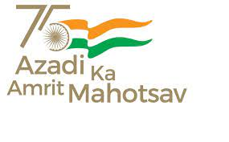**Govt. Aizawl North College**

**Ramhlun North Aizawl : Aizawl :Mizoram**

Website:http://www.ganc.mizoram.gov.in E-mail:govtanc@yahoo.com Phone:0389-2344069

_________________________________________________________________________________**No.A.60014/2/08 - GANC/CIR/  *Dated Aizawl, the 25th July, 2022***

**NOTIFICATION**

Dt. 27th July, 2022(Wednesday) hian kan College ah **Ujjwal Bhavishya** **Power @ 2047 Campaign** neih tur a ni a. He hunah hian 5th Semester zirlai Economics, Mizo, Political Science leh Geography core zawng zawng tel vek tur a hriattir kan ni e. Professor class neilo te pawh tel tur a hriattir leh ngen kan ni e.

Chief Guest : Lalrinenga, Mayor AMC

To be Address by : Dr. Lalhriatzuali Ralte, IAS, DC, Aizawl District

A hun : 11:00 Am to 12:30 Pm

A hmun : Professor’s Common Room

Sd/-

**(Prof. S. HAUKHANLIAN MATE)**

Principal

Govt. Aizawl North College

Aizawl:Mizoram.

**Memo: No.A.60014/2/08 - GANC/CIR/  *Dated Aizawl, the 25th July, 2022.***

Copy to :

1. Vice Principal for information.

2. Coordinator, IQAC for information.

3. HOD Geography, Economics, Mizo and Pol. Science for information and necessary action.

4. All professor for information.

5. Guard file

Principal

Govt. Aizawl North College

Aizawl:Mizoram.